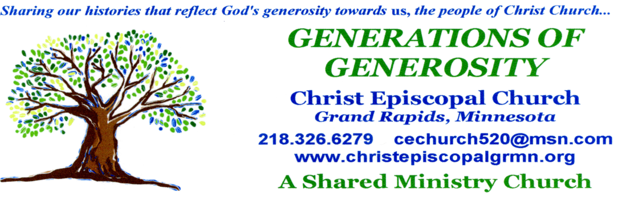
Edition #12 December 2020
www.christepiscopalchurchgrmn.org

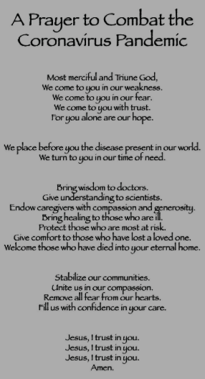


Prayer List
Molly Vergin, Kathleen, Cathy Daniels, Laura, Brian Lehinger, Henry, Nicole Schrag,
Janelle Erickson, Kathy Schmit, Erica, Josie, Mary Lou, Johannas, David, Jim Morlan,
Carla




Vestry did not meet in November; no minutes available.

December Birthdays  and Anniversaries  December  4 – Nathan Huntley  6 – Jennifer Kent, Jamie Morlan  9 – David DeLung  17 – Nancy Block  19 – Bette Ostgarden  21 – Elizabeth Huntley  22 – Georgia Finke | Server Schedule for December  There is no serving schedule for December.  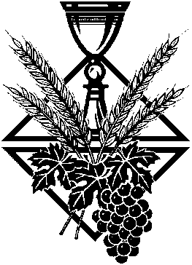

Shared Ministry Report


The November team meeting was postponed to December 1 due to the Thanksgiving holiday. Minutes will be in the January newsletter.

An invitation from Maria Annoni and the Spirit of Christ, the Healer community to join them in a virtual book study during Advent, on Zoom:
Perhaps more than any other time, our lives might be enriched through reading, and sharing our thoughts and memories about the first Christmas story. This is an invitation to join a VIRTUAL book study, centered on Amy Jill Levine’s, “Light of the World: A Beginner’s Guide to Advent.” The sessions on Zoom will span 4-6 weeks (depending on how our discussions develop), on Wednesdays, beginning December 2nd, at 6:15/6:30 PM (to be decided).

Some of you may already be members of the Amy-Jill Levine fan club, from a past book group (Short Stories by Jesus). If so, be patient while I sing her praises and highlight her credentials for those of you unfamiliar with this internationally renowned Professor of New Testament & Jewish Studies at Vanderbilt University. I urge you to read more about her online.



In Light of the World: A Beginner’s Guide to Advent, Levine explores the biblical texts surrounding the story of the birth of Jesus. Join her as she traces the Christmas narrative through the stories of Zechariah and Elizabeth, Mary, the journey to Bethlehem, and the visit from the Magi. These stories open conversations around connections of the Gospel stories to the Old Testament, the role of women in first-century Jewish culture, the importance of Mary’s visitation and the revolutionary implications of Mary’s Magnificat, the census and the stable, and the star of Bethlehem and the flight to Egypt.

This book is available through amazon.com (Paperback--$14.29, Kindle—7.99/9.99, audio book—free)
It is also available from the publisher, Abingdon Press, www.abingdonpress.com.

If you would like to give this Book study group a try, please contact Sally 218-244-7119 so we can get your email address to Maria for the Zoom invitation. If you don’t have your book by December 2, you can still join us for discussion.

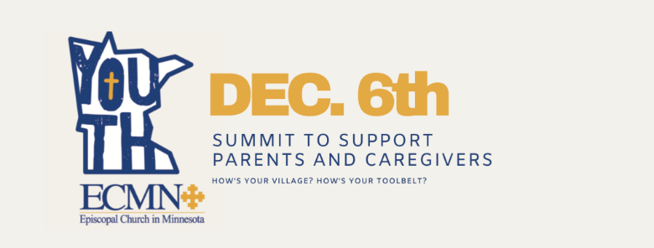

Bishop's Summit for ECMN Parents & Caregivers

Walking alongside young people as they navigate the complexities of life in the world has never been easy. But this year in particular, the complexities have grown exponentially.
Now, many of us are facing a dual challenge: learning to interpret and act given these new challenges ourselves, and then seeking to help the young people in our lives interpret this world that they are inheriting.
The challenge is great, and we can’t do this alone. So, come and chat back and forth with your new Bishop, as well as have breakout room conversations with other Episcopal parents in small groups with similar age kids.

Date/Time: Sunday, December 6 @ 4-5pm on Zoom
Register For Free Now (Control/click to display the link to register)

From Sally: All the parents of children at home, for whom we have an email address, have been sent this information. I am really pleased that our new Bishop is so interested in how parents in ECMN are doing. This has been such a stressful, anxious, and confusing year with so many changes and disruptions. Bishop Craig has a 4-year-old and a 9-year-old so he has experienced these challenges, as well. I hope some of our parents with children at home will check out this one-hour ‘summit’.

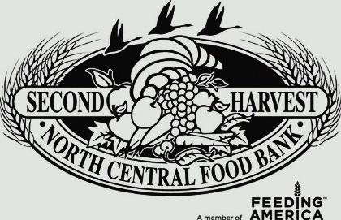
Please consider a donation to Second Harvest Food Bank during this Christmas season. The need is great; children are currently home from school on distance learning. The Food Bank can stretch monetary donations much further than we can and buy many more items than can be purchased by us at retail. If you do go shopping and are wondering what kinds of items could be really useful to them at this time, I was told that shelf-stable proteins like canned tuna, chicken, and salmon, peanut butter, and packaged almonds or other nuts are good choices. They also would be happy to receive donations of shampoo or body wash, and for babies, diapers and baby shampoo would be welcomed. They do not receive a lot of personal hygiene items but they are useful.
If you wish to send a donation, you may make a check payable to “Second Harvest” and mail it to:
Second Harvest
PO Box 5130
Grand Rapids MN 55744
If you have further questions, please call the Food Bank at 218-326-4420.

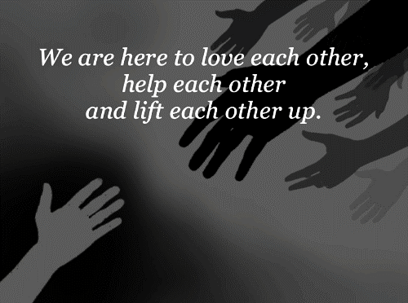

December 24, 2020

ECMN Lessons and Carols
Online
This Christmas, ECMN will be putting together a Festival of Nine Lessons and Carols service that will be live streamed on Facebook and Vimeo both on Christmas Eve at 7pm, and then again on Christmas Day at 10am.
It will feel very strange not to be having our usual Christmas Eve services this year since Christ Church continues to be closed due to the ongoing pandemic. The team will be having a final discussion this week at our monthly meeting and we will likely decide that our Christmas Eve service this year will be the service of the Christmas Festival of Nine Lessons and Carols being produced and live streamed on Christmas Eve and Christmas day by the Episcopal Church in MN (ECMN).This beautiful service of Christmas Lessons and Carols is based on the medieval vigil service and has its roots at King's College Chapel in Cambridge, England. It is a series of Scripture readings telling the story of our salvation history, with appropriate carols and hymns. It is similar to our annual service of Advent Lessons and Carols but with familiar, beloved Christmas Carols.
Please keep your eye on upcoming weekly emails for information about how to view this service and I hope you will consider participating in this online service as your Christmas worship.
-Sally +

Christ Episcopal Church
520 North Pokegama Avenue
Grand Rapids, MN 55744
Phone: 218-326-6279
Web Site: christepiscopalchurchgrmn.org
Email:cechurch520@msn.com
Christepiscopalchurchgrmn@groups.facebook

Church Office Hours:
Mon., Wed., Thurs., Fri. 10:30 a.m. – 3:30 p.m.
(Kelly is off on Tues.)
Church Phone Number: 326-6279
Please plan to attend the free catered luncheon following the 10 am service on November 25th. This will be the culmination of the Stewardship Drive and the Silent Auction items will be awarded.

