
Edition #1 January 2021
www.christepiscopalchurchgrmn.org

Shared Ministry Report


Total Ministry Team Meeting - December 1, 2020 (via zoom)
Attendance: Rev. Sally Cummings, Kim Heise, Rev. Rhonda Ruder, Rev. Jill Schubert
The following topics were discussed at the team meeting:
- Christmas services: The ECMN service (which will be Christmas Lessons and Carols) will be held at 7 p.m. on Christmas Eve and again at 10 a.m. on Christmas day. It can be viewed on the ECMN Facebook page or on VIMEO. Reverend Sally will provide an evening prayer service to parishioners who do not use the computer. A regular morning prayer service will be held on zoom on Dec. 27th.
- Discussion of upcoming services and “reflection” schedule.
- There will be a meeting with the parishes of Virginia/Eveleth and Hibbing to explore the possibility of some joint Morning Prayer services with Christ Church, perhaps monthly. Kim Heise and the Rev. Rick Swenson from Sts. John and Paul in Virginia will facilitate this meeting. This would be a ‘relationship-building’ opportunity with other very small Episcopal churches in our area.
- Kim Heise, who is in the midst of her Diaconate training, is proposing that she might be a deacon to churches on the “Range” once she is ordained and therefore still be able to participate with Christ Church in the upcoming months and years. It is easy to participate and help churches across the range in the time of Zoom with no in-person services, but will be more of a challenge once we are back to in-person worship.
- Rev. Rhonda Ruder is working on some Advent and Christmas activities with the youth. Rev. Sally has attended a presentation on Gen Z (regarding those born between 1997-2015) and shared information that youth in Gen Z tend to value relationship, safety, and inclusiveness.
- Rev. Sally attended a meeting with the Bishop and others regarding total ministry experiences. The Bishop has set up a Diocesan committee to look at small rural parishes and the use of total ministry. This will assist in looking at the needs of small parishes and how shared ministry might fit into the future of smaller congregations.
- There was a discussion of Holy Eucharist. Several ideas were presented. The Bishop has written a reflection on the Eucharist and its place in worship in this time of pandemic and the absence of in-person worship. (The reflection is available on the ECMN website). Rev. Sally Cummings will talk with the Bishop to clarify what options might be available in our context. More discussion will follow.
If anyone has questions, concerns, or items to be discussed, please feel free to contact me or any team member.
Rev. Sally Cummings




Prayer List
Molly Vergin, Kathleen, Laura, Brian Lehinger, Henry, Barb Erickson, Erica,
Josie, Johannas, David, Jim Morlan, Syd, Kari, Jason, Chris, Ron Rasmussen




Vestry did not meet in December; no minutes available.

January Birthdays  and Anniversaries  January  1 – Kelly Karkiainen  2 – Arlene Kantos  10 – Bruce Humrickhouse  11 – Jill Schubert  17 – Hannah Hodgson  Heather Lehinger  19 – Larry Heise  20 – Rhonda Ruder  23 – Carla Hodgson | Server Schedule for January  There is no serving schedule for January  
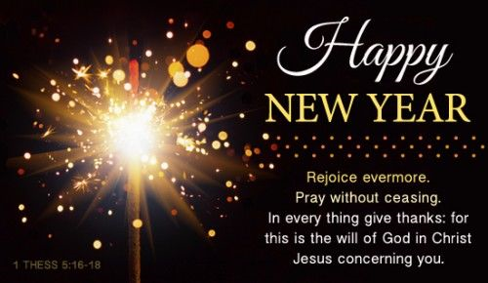


Safe Church Training
During these long days at home, you may wish to update your Safe Church training. Most of you are due to be updated, and there is new information for the Safe Guarding God’s People training.
Just a reminder: All persons with a key to the church, all youth leaders, all vestry members, all employees, and all team members need to take the Safeguarding God’s Children training,
and
All team, vestry, and employees need to take the Safeguarding God’s People training.
If you have a computer, this training can be taken online. Just go to ECMN and click on the Safe Church tab. You can then select the training and register. The trainings are scheduled each month and last about 3 hours.
When you have completed the training, please email me at rschub45@hotmail.com and I will update the data base.
I will resume live training once the church is back in session, but this might be a chance to update at your leisure.
Rev. Jill Schubert

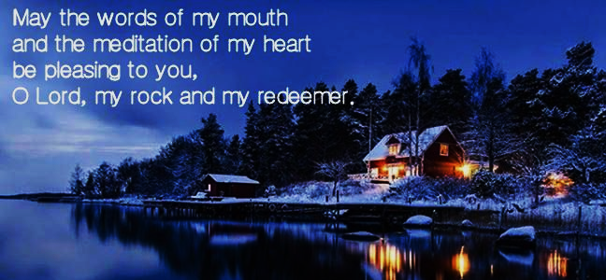
Psalm 19:14

4 Prayers of Hope for the New Year
As we say goodbye (good riddance?!) to 2020, it’s time to turn the page, even a corner.
by Bob Hostetler Posted in How to Pray


For many of us, 2020 has been a year like no other—so much has been disruptive, stressful, disturbing and even traumatic. It seems as though we’ve been through one disappointment, derailment and disaster after another. We never asked for such a stormy year, but we weathered it. Now we turn a page, a corner. We may even turn over a new leaf.
So, what should we pray as we say goodbye—perhaps good riddance—to 2020? Here are four suggestions. You can fill in your own petitions and names to tailor these prayers to your life and needs.
1) Pray to Process the Past
For many of us, these past 12 months came at us so fast that we had no time to think or recover before the next crisis hit. So, it may be wise here, at year’s end, to breathe a bit more deeply and think reflectively. A prayer such as the following may help:
God, clear my mind and help me to process all I’ve been through in 2020.
Give me wisdom. Enlighten me.
Help me, especially, to see Your hand in _______.
What were the moments when I drew closer to You?
When I strayed from You?
When I forgot that You were there, that You are always there?
What did I learn? What do I still need to learn in order to move on from 2020?
2) Pray to Remember…and Forget
There are, of course, many things about this past year that we would like to forget. But let’s not be too hasty. Perhaps a prayer like the following may help make peace with regrets and nurture hope for a fresh start:
God, this has been a year filled with loss and pain.
Hold my hand as I grieve the losses and bear the pain, especially _______.
Hear my prayer as I confess my sins and surrender my regrets, especially _______.
Wipe from my memory the things that aren’t worth carrying into 2021, especially _______.
Help me to hold onto 2020’s lessons, blessings and victories, especially _______.
3) Pray to Look Ahead in Newness, Hope, Faith and Love
Many of us saw our plans for the year demolished as 2020 got underway. But that doesn’t mean we can’t create new dreams for 2021:
God, I’m sure You understand my trepidation as I anticipate the new year. So little in 2020 went according to plan.
But those were my plans, I admit, and a new year unfolds before me.
Let this new year mark the beginning of newness of life for me and mine.
Let this year dawn in hope and proceed in hope; let the “deferred” hope of 2020 blossom into fruitful fulfillment in 2021 (see Proverbs 13:12). Give me hope especially for _______.
Let this year deepen and strengthen my faith in You, especially as concerns _______.
And let 2021 be a year in which Your love is shed abroad in my heart and the hearts of those around me, especially _______.
4) Pray to Begin Anew
And with new plans and dreams on the horizon, here’s a prayer to open your heart to receiving God’s love and guidance as you begin to put them in place:
God, let this new year mark a new beginning for me and those I love.
Grant us, and especially _______, a new sense of Your closeness and care.
Give new strength and vitality, especially for _______.
Send a new level of hopeful trust to me, a new sense of your closeness and care, especially when _______.
Fill 2021 with new love, new joy and new peace;
with new outpourings of patience, kindness, goodness and faithfulness;
with new infillings of gentleness and self-control (see Galatians 5:22).
Let this coming year be ruled by whatever is true, whatever is honorable, whatever is right, pure, lovely, admirable, excellent and worthy of praise (see Philippians 4:8).
Let those prayers be only a starting point for the end of 2020 and the year to come. Pray that 365 days from now, you’ll look back with praise and thanksgiving on all of the ways God answered, even beyond what you thought to ask (see Ephesians 3:20).
Christ Episcopal Church
520 North Pokegama Avenue
Grand Rapids, MN 55744
Phone: 218-326-6279
Web Site: christepiscopalchurchgrmn.org
Email:cechurch520@msn.com
Christepiscopalchurchgrmn@groups.facebook

Church Office Hours:
Mon., Wed., Thurs., Fri. 10:30 a.m. – 3:30 p.m.
(Kelly is off on Tues.)
Church Phone Number: 326-6279
Please plan to attend the free catered luncheon following the 10 am service on November 25th. This will be the culmination of the Stewardship Drive and the Silent Auction items will be awarded.

